# Work Instruction: EZ Metadata Creator – EMEA

**Purpose**  
Generate metadata files (Excel and CSV) for environmental restrictions applied to vehicles based on zone, days, time, and vehicle characteristics.  
On the Home page, select the designated zone:

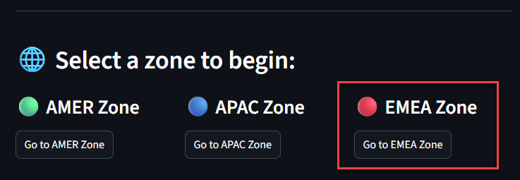

Link: <https://2raxaxqzarwdf6ffwlnacj.streamlit.app/EMEA_Zone>

**EZ Metadata Creator - EMEA**

**City Identification**  
In this first section, you must enter the exact name of the zone or city, as well as its identifier.

**Vehicle Types**

Here you will find the full list of vehicle categories to which a restriction can be applied. You may select a single option or multiple available options.

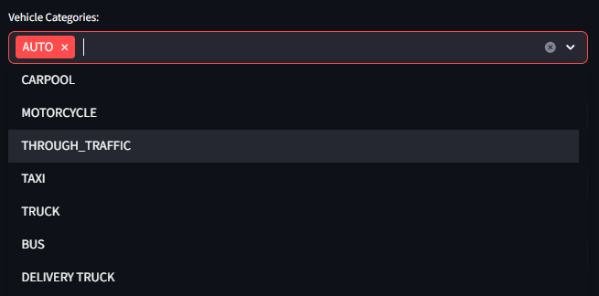

**Restrictions**

This section is essential to indicate the type of restriction that will apply in the metadata.  
The following restriction types are available:

***EMISSION STANDARD***

For ***Vehicle Restriction***: EMISSION STANDARDSelect this option when vehicle circulation is restricted based on the type of emissions they produce. This restriction is only applied in zones that follow European standards.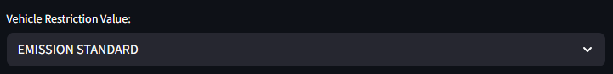

For **EzTag**: Select Emission Standard  
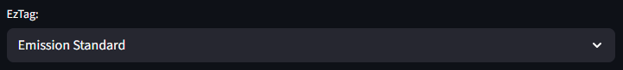

***FUEL TYPE***

For ***Vehicle Restriction***: FUEL TYPESelect this option when vehicle circulation is restricted based on the type of fuel used.

For **EzTag**: Select Fuel Type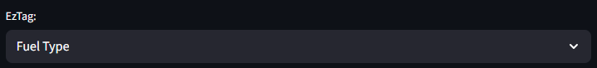

***MAX NUMBER OF PASSENGERS***

For ***Vehicle Restriction***: MAX NUMBERS OF PASSENGERSSelect this option when vehicle circulation is restricted based on the number of passengers onboard.  
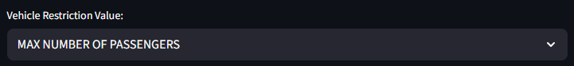

For **EzTag**: Select Max Numbers Of Passengers  
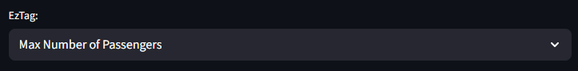

***COMMERCIAL***

For ***Vehicle Restriction***: COMMERCIALSelect this option when the circulation of vehicles used for commercial activities or goods transport is limited.

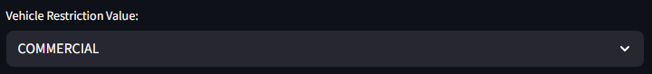

For **EzTag**: Select Commercial  
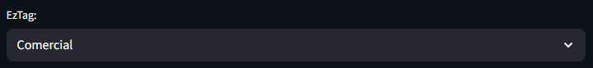

***ENVIRONMENTAL BADGE***

For ***Vehicle Restriction***: ENVIRONMENTAL BADGESelect this option when circulation is limited based on the vehicle’s classification, typically determined by a sticker.  
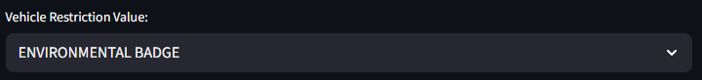

For **EzTag**: Select Environmental Badge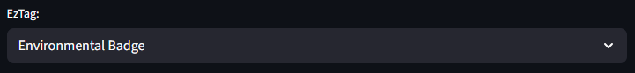

***ABSOLUTE VEHICLE AGE***

For ***Vehicle Restriction***: ABSOLUTE VEHICLE AGESelect this option when circulation is limited based on the vehicle’s specific age, generally measured in years since manufacturing.

For **EzTag**: Select Absolute Vehicle Age  
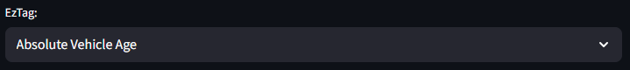

***RELATIVE VEHICLE AGE***

For ***Vehicle Restriction***: RELATIVE VEHICLE AGESelect this option when circulation is limited based on the vehicle’s general age, also typically measured in years since manufacturing.

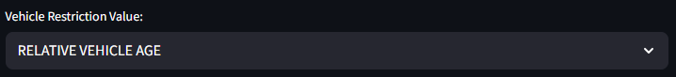

For **EzTag**: Select Relative Vehicle Age  
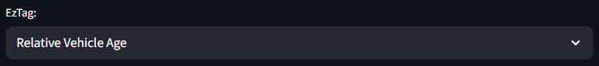

***OVERRIDE***

For ***Vehicle Restriction***: OVERRIDESelect this option when the zone has the possibility to exempt vehicles from restrictions.

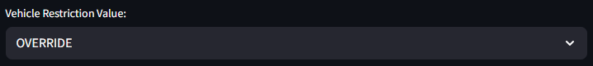

For **EzTag**: Select Override

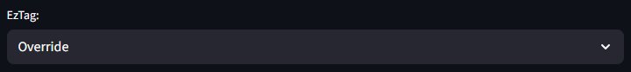

***MAX TOTAL WEIGHT***

For ***Vehicle Restriction***: MAX TOTAL WEIGHTSelected when the restriction is based on the maximum allowed vehicle weight for circulation.

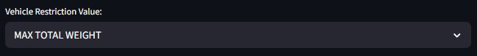  
  
For **EzTag**: Select Max Total Weight  
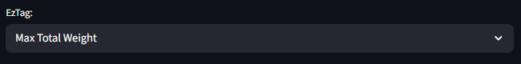

***MIN TOTAL WEIGHT***

For ***Vehicle Restriction***: MIN TOTAL WEIGHTSelected when the restriction is based on the minimum allowed vehicle weight for circulation.  
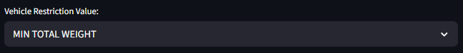

For **EzTag**: Select Min Total Weight  
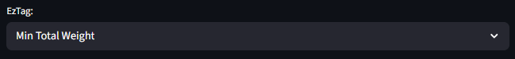

**Start Day / End Day**

Defines the date range during which the restriction applies.  
These dates indicate the starting and ending month and day of enforcement.  
If the restriction applies only by month, use this section as well.

**Example:**  
If the restriction applies from April to September (04–09), only the months are needed.

* **Start Day**: Select any day in April.

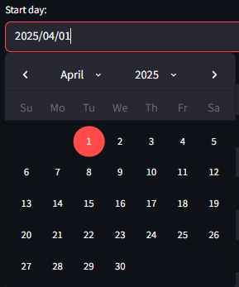

* **End Day**: Select any day in September.  
  A screenshot of a calendar

  AI-generated content may be incorrect.

**Time Range**Indicates the hours during which the restriction is enforced.  
If the restriction does not require a time range, no action is needed in this field.  
If you need to remove this field, delete it directly from the EPAC metadata output.



**EZ Description**Write a general description of the restriction.  
If you need additional entries, add them directly in the EPAC metadata output.



**Lang Description**Indicate the language used for the description.  
If you need additional values, add them directly in the EPAC metadata output.

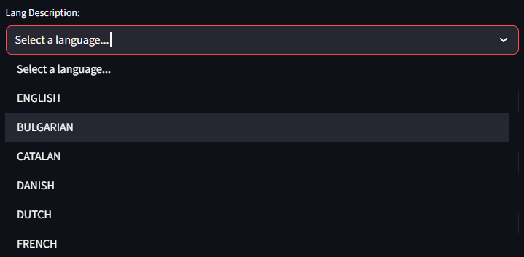

**Website for EZ**Insert the official URL where the restriction information for the EZ zone is published.  
If you need more values, add them directly in the EPAC metadata output.



**Days to Apply Restriction**Here you will find all the days available for applying the restriction. You may select from one to all seven days of the week.

**Restriction Values**

**Restriction Values for EMISSION STANDARD**The following input will appear to indicate the emission standard:

The Euro emission standards are a set of environmental regulations established by the European Union (EU) to reduce harmful emissions from new vehicles with internal combustion engines.

* Euro 1 emission standard (1992):  
  CO limit at 2.72 g/km and combined HC+NOx at 0.97 g/km for both petrol and diesel. PM limit of 0.14 g/km for diesel.
* Euro 2 emission standard (1997):  
  CO at 2.2 g/km and combined HC+NOx at 0.5 g/km for petrol.
* Euro 3 emission standard (2001):  
  Introduced separate NOx limits for diesel and individual HC and NOx limits for petrol.
* Euro 4 emission standard (2006):  
  Petrol: CO – 1.0 g/km, HC – 0.10 g/km, NOx – 0.08 g/km  
  Diesel: CO – 0.50 g/km, HC+NOx – 0.30 g/km, NOx – 0.25 g/km, PM – 0.025 g/km
* Euro 5 emission standard (2009/2011):  
  First time a PM limit was introduced for petrol engines with direct injection.
* Euro 6 emission standard (2014 onward):  
  Petrol: CO – 1.0 g/km, HC – 0.10 g/km, NOx – 0.06 g/km  
  Direct injection petrol: PM – 0.005 g/km, 6.0 × 10^11 particles/km  
  Revisions in 2018, 2019, 2021, and 2022.

**Restriction Values for FUEL TYPE**The following input will appear listing various fuel types.

*Types of fuel include:*

* **CNG** (Compressed Natural Gas): High-pressure gaseous fuel mainly composed of methane.
* **DIESEL**: Petroleum-based liquid fuel used in diesel engines.
* **HYDROGEN**: Chemical element used in fuel cells to generate electricity.
* **LNG** (Liquefied Natural Gas): Natural gas cooled into a liquid for easier transport.
* **LPG** (Liquefied Petroleum Gas): Flammable hydrocarbon gas mixture, mainly propane and butane.
* **PETROL** (Gasoline): Petroleum-derived liquid fuel used in gasoline engines.

*Propulsion technologies:*

* **ELECTRIC**: Powered only by electric motors using battery-stored electricity.
* **HYBRID**: Combine internal combustion engines with electric motors, using both petrol and electricity.
* **PLUGIN HYBRID**: Can be plugged in to recharge; offers electric and hybrid driving modes.

**Restriction Values for MAX NUMBER OF PASSENGERS**An input will appear to indicate the maximum number of passengers (numeric values only).  
If you require additional numbers, please request them from the developer.

**Restriction Values for COMMERCIAL**An input will appear to select the commercial vehicle restriction value.

**Restriction Values for ENVIRONMENTAL BADGE**An input will appear to select the appropriate environmental sticker value.

**Restriction Values for ABSOLUTE VEHICLE AGE**An input will appear requiring selection of a **specific date** for the restriction. 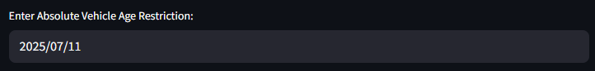

**Restriction Values for RELATIVE VEHICLE AGE**An input will appear requiring selection of a **general date** for the restriction.

**Restriction Values for OVERRIDE**An input will appear with available override values. Select according to the restriction conditions.

* **LICENSE PLATE**: When the override is applied based on the license plate.
* **COST**: When the override is based on a fee or payment.
* **RESIDENTIAL**: When the override applies only to residents of the zone.

**Restriction Values for MAX/MIN TOTAL WEIGHT**  
An input field will appear where you can enter the weight value. Enter numeric values only.

**Previous Data Display**

This display shows the selected data before generating the metadata. Its purpose is to help verify that the input information is correct.  
Records are generated by vehicle type followed by the indicated date ranges.

To display the data, click the **Generate Records** button. Each time you click this button, the system saves the input values. This allows you to modify the inputs and include different restrictions and values in the same metadata file.

**Example – Combined Restriction: Max Total Weight + License Plate**

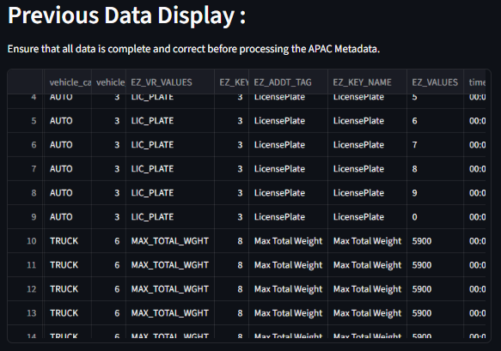

**Metadata APAC**

Once all data is verified in the display, click the **Create APAC Metadata** button.  
This will generate the following sheets:

* **EZ_ADDT_RESTRS_UMRDomainComboRecord**  
  This sheet is generated only for LICENSE PLATE NUMBER restrictions and indicates a record per numeric value.

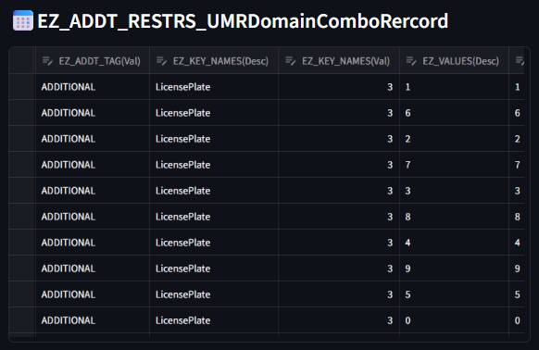

* **EZ_RESTR_UMRDomainComboRecord**  
  This sheet shows the restriction values and the vehicle types to which they apply.

* **EZ_TIME_RESTR_UMRDomainComboRecord**  
  This sheet includes the time-related values of the restriction: hours, dates, days, and months.

* **EZ_VEH_RESTR_UMRDomainComboRecord**  
  This sheet indicates which vehicle types the restriction applies to.

* **EZ_DESCRIPTION_UMRDomainComboRecord**  
  This sheet contains the written description of the restriction and the language used.

* **EZ_WEBSITE_UMRDomainComboRecord**  
  This sheet lists the official source(s) where the restriction information was obtained.

* **EZ_POLYRESTR_UMRDomainComboRecord**  
  This sheet defines the polygonal restriction area, based on the vehicle data.

* **EZ_DATES_UMRDomainComboRecord**  
  This sheet contains the restriction modification dates.  
  ⚠️ *This must be filled manually by the assigned DBE in Excel.*

**For a New City:**

If the metadata is for a newly created city/zone, please select the **"NewCity"** checkbox:



Once selected, the following input fields will appear:

* **Select Country**  
  Choose the country where the new city/zone is located.

* **Select EZ Category Feature**  
  Choose the category type of the environmental zone:
  + **Polygonal Feature**: The restriction applies within a specified polygon.
  + **Linear Feature**: The restriction applies only on selected links.

This will generate the following sheets:

* **ENVZONE_UMRDomainValue**  
  Lists the name-ID record of the new city/zone.

* **ENVZONE_CHAR_UMRDomainCombo**  
  Defines the type of environmental restriction for the new zone.

**Reminder:**  
You can edit any value directly in the generated tables. For bulk modifications, download the file and make changes manually in Excel.

The last button, **“Download APAC Metadata Excel File”**, downloads the APAC Metadata including all the sheets previously mentioned.

**MMT Files Processor**

This section is dedicated to generating the files required to upload into the Metadata Management Tool (MMT).

This tool can be used in two ways:

1. **Use Previous Data**  
   This button requires that the APAC metadata is already created and active within the same application.
2. **Upload External Excel File**  
   This option allows you to upload an external metadata file.  
   It’s useful in cases where manual sorting/editing/deletion was performed in Excel before creating the MMT files.  
   This method works independently and does not require complete metadata.

The tool generates the following files:

* **ADD_EZ_ADDT_RESTRS DataFrame**  
  Generated only if the metadata includes the EZ_ADDT_RESTRS_UMRDomainComboRecord sheet.

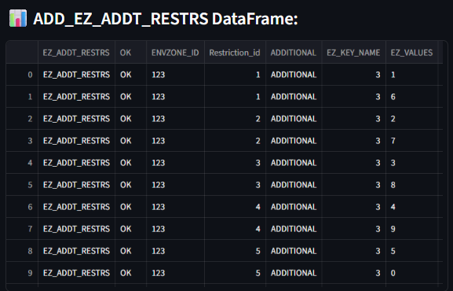

* **ADD_EZ_REST DataFrame**

* **ADD_EZ_TIME_RESTR DataFrame**

At the end, the tool shows three buttons to download each file individually.

⚠️ **Need help?**  
If you have any special requirements or suggestions for improving the tool, feel free to contact the EZ - LDO development team. We’ll gladly get in touch to work on your idea.